Guringai History
Spelling variations

Boydell, R. H. Mathews - Gooringgai, William Scott – Gringai, John Fraser - Goringai, Kuringgai and Kurig-gai. Other spellings, Cooringay, Guringai, Gooreeggai, Goreenggai, Gourenggai, Gingai, Gooreenggai, Gringai, Corringorri, and Amanda Lissarrague- Guringay

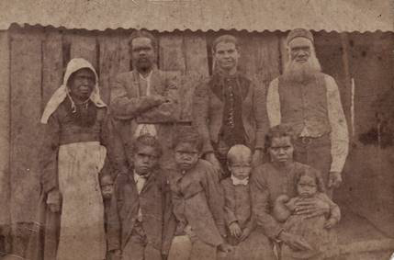
The Cook and Brummy Family around 1890 Barrington NSW Aboriginal camp Photo back row left is wife Jessie Cook (nee Brummy) and far right back row husband (Jack Cook – initiated name Muligat lightning) with family
By Luke Russell and Robert Syron
The Guringai, people are the traditional custodians of the land between the Hunter and Manning Rivers, from the ocean to and including the Great Dividing Range. A saltwater people whose land extended inland as far as the salt pushed. From modern day Newcastle to Singleton, on the northern side of the Hunter, through the Barrington’s and back down the Manning to the ocean. This is traditional Guringai country. Bordering the Birripai speaking people of the north, the Awabakal people to the south and the Wannarua and Kamilaroi people to the west.
Descending from one of the four traditional nations of our language group, we have continued the strong connection to our old people, our old ways, our country, our language, our stories and our kinship. Traditionally our language group encompassed the lands between the Hawkesbury and Hastings, the ocean and the mountain ranges. Our ceremonial, kinship and marriage ties would take us further into the northern and southern bordering language groups.

The Gringai, Worimai and Biripai are language dialects of the traditional custodians. Thankfully our language is well recorded with over 6,000 words and importantly voice recordings over an extended time. From the early 1800’s to the 1970’s various recordings were taken from Port Stephens, Gresford, Taree, Port Macquarie, the upper Manning and the Barrington’s. Allowing us to re-awaken our traditional dialects and speak the language of our old people.

Our stories lines connect us to the four corners of our language group, tying us to our surrounding nations, the country and sea. We have been fortunate to have our traditional stories passed down through the generations, in turn we are now privileged in maintaining our connection and most importantly we keep our old people alive by doing so.
The respect and gratitude to all of our old people who have gone before us is of the utmost importance to us. For if it wasn’t for all those people playing their role’s, we wouldn’t be in the position we are in today. Being able to continue all of their amazing stories.
We are the only kuringai, Kuring-gai, Cooringay, Guringai, Gooreeggai, Goreenggai, Gourenggai, Gingai, Gooreenggai, Gringai, Corringorri, Guringay and Goringai People.
My name is Bob Syron Born 1965 Registered Aboriginal Owner of Worimi conservation lands Port Stephens Guringai language group. kabook and Watoo people https://hunterlivinghistories.com/2018/08/15/the-kabook-watoo/
I am a descendant of the Cook and Clarke family’s.My Aboriginal grandmother, was Eileen May Syron (Nee Cook) Born 1911 on the Barrington River NSW and was the granddaughter of Muligat- Lightning- AKA - Jack Cook and Jessie Cook- Nee Brummy.
My Aboriginal Grandfather was Robert J Syron Born 1901 grandson of Robert Clarke and Susanna Clarke-Nee Mayers Manning River Forster NSW. Robert J Syron and Eileen May Syron together they had 16 children.

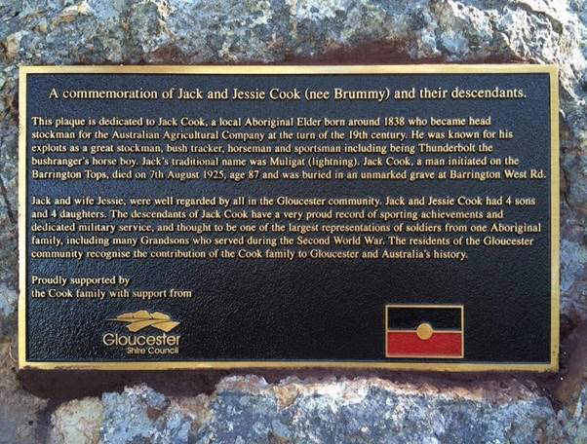
Gloucester Billabong Park memorial NSW

Guringai History
Spelling variations

Boydell, R. H. Mathews - Gooringgai, William Scott – Gringai, John Fraser - Goringai, Kuringgai and Kurig-gai. Other spellings, Cooringay, Guringai, Gooreeggai, Goreenggai, Gourenggai, Gingai, Gooreenggai, Gringai, Corringorri, and Amanda Lissarrague- Guringay

The Cook and Brummy Family around 1890 Barrington NSW Aboriginal camp Photo back row left is wife Jessie Cook (nee Brummy) and far right back row husband (Jack Cook – initiated name Muligat lightning) with family
By Luke Russell and Robert Syron
The Guringai, people are the traditional custodians of the land between the Hunter and Manning Rivers, from the ocean to and including the Great Dividing Range. A saltwater people whose land extended inland as far as the salt pushed. From modern day Newcastle to Singleton, on the northern side of the Hunter, through the Barrington’s and back down the Manning to the ocean. This is traditional Guringai country. Bordering the Birripai speaking people of the north, the Awabakal people to the south and the Wannarua and Kamilaroi people to the west.
Descending from one of the four traditional nations of our language group, we have continued the strong connection to our old people, our old ways, our country, our language, our stories and our kinship. Traditionally our language group encompassed the lands between the Hawkesbury and Hastings, the ocean and the mountain ranges. Our ceremonial, kinship and marriage ties would take us further into the northern and southern bordering language groups.

The Gringai, Worimai and Biripai are language dialects of the traditional custodians. Thankfully our language is well recorded with over 6,000 words and importantly voice recordings over an extended time. From the early 1800’s to the 1970’s various recordings were taken from Port Stephens, Gresford, Taree, Port Macquarie, the upper Manning and the Barrington’s. Allowing us to re-awaken our traditional dialects and speak the language of our old people.

Our stories lines connect us to the four corners of our language group, tying us to our surrounding nations, the country and sea. We have been fortunate to have our traditional stories passed down through the generations, in turn we are now privileged in maintaining our connection and most importantly we keep our old people alive by doing so.
The respect and gratitude to all of our old people who have gone before us is of the utmost importance to us. For if it wasn’t for all those people playing their role’s, we wouldn’t be in the position we are in today. Being able to continue all of their amazing stories.
We are the only kuringai, Kuring-gai, Cooringay, Guringai, Gooreeggai, Goreenggai, Gourenggai, Gingai, Gooreenggai, Gringai, Corringorri, Guringay and Goringai People.
My name is Bob Syron Born 1965 Registered Aboriginal Owner of Worimi conservation lands Port Stephens Guringai language group. kabook and Watoo people https://hunterlivinghistories.com/2018/08/15/the-kabook-watoo/
I am a descendant of the Cook and Clarke family’s.My Aboriginal grandmother, was Eileen May Syron (Nee Cook) Born 1911 on the Barrington River NSW and was the granddaughter of Muligat- Lightning- AKA - Jack Cook and Jessie Cook- Nee Brummy.
My Aboriginal Grandfather was Robert J Syron Born 1901 grandson of Robert Clarke and Susanna Clarke-Nee Mayers Manning River Forster NSW. Robert J Syron and Eileen May Syron together they had 16 children.

Gloucester Billabong Park memorial NSW

